**DEPARTMENT OF ELECTRICAL ELECTRONICS ENGINEERING TECHNOLOGY, FEDERAL POLYTECHNIC, MUBI, ADAMAWA STATE**

**PROPOSED TOPIC:**

**DESIGN AND CONSTRUCTION OF A RECHARGEABLE VARIABLE POWER SUPPLY (1 to 30 volt)**

**by**

**PAUL USAKO**

**Et/EE/hnd/21/006**

**supervised by**

**ENGR. ALHAJI AMINU YA’U**

**june, 2023**

**Chapter one**

**INTRODUCTION**

**1.1 Background of the Study**

Development in the field of electronic have provided different technological approach used for upgrading and improving the standard DC voltages, communication instrumentation control etc. electronics perhaps more than any other field of technology, has enjoyed an explosive development. Generally, in electronics all electrical instrument and circuit require a source of direct current (DC) power before they operates, it Is either from a battery or a AC source (Hoftman, 2013).

According to Theraja and Theraja (2008) opines that most of electronic devices ad circuit require a d.c source for their operation. Dry cells and battery are one form of d.c source. Those type of dc source voltages are low; they need frequent replacement and are expensive as compared to conventional d.c. power supply (Adeite & Osemelikilali, 1996).

A power supplies have a power input which receives energy from the energy source. and a power output that delivers energy to the load. Most power supply the power input and output consist of electrical connectors or hardware circuit connection (John, 2020). The circuit mainly compose of the input transformer which will be used to transform the incoming line voltage down to the required level for the power supply, the power supply rectifier covert the AC voltage to DC voltage either halfwave or full wave, the addition of a reservoir capacitor here fills In the troughs in the wave form, enabling the next stage of power supply to operate, large value and capacitor are to be used in this stage (Robert & Louis 2004). The voltage adjuster of the power supply takes the smoothed voltage and use a variable integrated circuit (IC) and potentiometer to provide a variable regulated output virtually regardless of the output current and any minor fluctuation in the input level (Study, 2014).

**1.2 Statement of the Problem**

For prototyping and hobbyist, appliance or gadget with smaller voltage, they normally use battery as power source, instead of using batteries which have limited lifetime and fixed output.

A variable DC power supply can be used which is been implemented as digital variable power supply (the output voltage may be varies as required by the user and display in the screen.

**1.3 Aim and Objectives**

The aim is to construct a variable power supply to provide the required power load using an AC supply at the input and variable regulated power from 1 to 24v at the output terminal and display the value on screen, by earning the voltage adjuster known as potentiometer, it allows analog control and power supply output for maximum versatility and other objectives to be achieved are:

1. To observe the output to meet the requirement.
2. To use the device for more than one purpose power supply and USB.
3. To use less costly components and portability.

**1.4 Significance of the Study**

This project if completed will make it possible for researchers to have power supply to run different devices of higher or low value.

The project does not require any external measuring device such as multimeter and others because the quantity obtained is being displayed on the screen.

The project can be used in basic electricity laboratory and other laboratory where different D.C. voltage is required for practical.

The project can be used in electronic workshop by technician for repairs and maintenance of electronic devices

**1.5 Scope and Limitation**

The scope of the study is conversion of A.C. voltage to D.C. voltage to be displayed and it is limited to 1.5 to 30 volt.

**CHAPTER TWO**

**LITERATURE REVIEW**

**2.1 Review of Related Literature**

This chapter briefly bring the history of a D.C. power supply and a survey and analysis of what has been written on previously similar project or research.

Thomas Edison invented direct current in the late 1870s and in 1920s crude device were ffirst developed to serve as battery eliminators to power radios in both commercial and consumer market. The market for separate power supplies rise around 1929, where most radios manufactured include a built in power supply. The need for stand alone power supply remained relative from 1930 to 1940 (Charles, 2021). In the early 1950s and early 1960s power supply produced adopting may-Amp technology satisfy the application at this time vibrators converts and an automobile 12volt high voltage D.C. by mechanically switching (Frank, 2022).

Thermion (vacuum tube) diodes and solid state (semiconductor) diodes were developed separately, at approximately the same time, in the early 1900s, as radio receiver detectors. Until the 1950s vacuum tube diodes were more often used in radios because semiconductor alternatives (Cat’s Whiskers) were less stable, and because most receiving sets would have vacuum tubes for amplification that could easily have diodes included in the tube (for example the 12SQ7 double-diode triode), and vacuum tube rectifiers and gas-filled rectifiers handled some high voltage/high current rectification tasks beyond the capabilities of semiconductor diodes (such as selenium rectifiers) available at the time.

Battery-base, battery-linear and linear power supply those that the most common once (Green, 1995).

**2.2 Related Research**

**2.2.1 Unregulated d.c. power supply**

An unregulated D.C power supply is one whose D.C terminal is affected significantly by the amount of load the major setback of this type of power supply is as the load draws more current, the D.C terminal voltage becomes less (Theraja & Theraja, 2008).

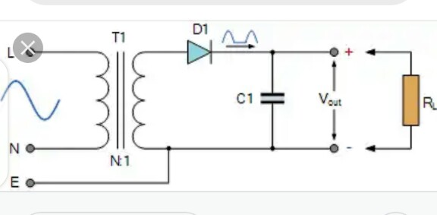

Figure 2.1: Unregulated power supply

**2.2.2 Voltage multipliers**

A voltage multiplier is a circuit which produce a greater D.C output than A.C input voltage to the rectifier. D.C voltage multiplier are required in application when it is necessary to have high voltage with low current as for electron accelerating purpose in cathode ray tube. This type of D.C power Supply is not suitable for low voltage appliance (Paul & Simon, 2012).

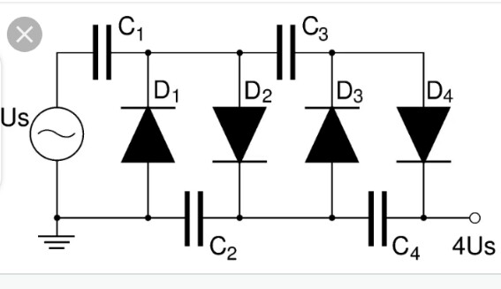

Figure 2.2: Voltage multiplier

**2.2.3 Battery base or battery**

Battery base power is a third type of power supply and is essentially a mobile energy storage unit with fixed output while battery consist of a electro chemical cell connected either in series or parallel is a power generating devices which is capable of converting stored chemical into electrical energy.

**CHAPTER THREE**

**3.1 Propose material and method**

The proposal material for the project are both active and passive electronic component. Most of the component to be used for this project are available, and the analog to digital converter is a module which will be connected to the constructed circuit.

**3.1.1 List of material**

|  |  |  |  |
| --- | --- | --- | --- |
|  | **Name** | **Value** | **Quantity** |
| 1 | Analog to Digital Converter | DT830D | 1 |
| 2 | Transformer step down | 240 50Hz 24 or 30V 3000 MA | 1 |
| 3 | Diode | IN 4001 | 6 |
| 4 | Capacitor | 2200uf 50V | 1 |
| 5 | Capacitor | 10uf 63V | 1 |
| 6 | Capacitor | 0.1uf | 1 |
| 7 | capacitor | 470uf 50V | 1 |
| 8 | Variable resistor | 10Kso | 1 |
| 9 | Resistor | 2.2kso 1watt | 1 |
| 10 | I.C | Lm 317 | 1 |
| 11 | Resistor | 1ks0 | 1 |
| 12 | LED | Red | 1 |
| 13 | Vero board | Copper lines | 1 |
| 14 | Connectors | Many | many |

**3.2 Method**

Electrical fabrication consists of electrical design that is making the construction of Vero board soldering and other connection, this project “digital variable DC power” will be constructed with transformer which will step down the AC to require value than the bridge rectifier, the rectifier signal is smoothed by the smoothing capacitor C1 when the supply is available it will be charged via diode and then to regulator.

After gathering the component required working out the strip board layout, having the circuit diagram laying the component as shown in the diagram. Placing the jumper where its requires, performing at the permanent soldering, connecting the external component such transformer analog to digital converter with the display unit to make it complicated.

**3.3 Expected Result**

|  |  |  |
| --- | --- | --- |
| **Circuit** | **Input** | **Output** |
| Transformer | 220VA.C | 30VA.C |
| Rectifier | 30V A.C | 32volt on load |
| Regulator | 30V D.C | 1 to 30 on load |
| Variable from 1 to 24 or 30volt D.C. display | | |

**3.3 Circuit Block Diagram**

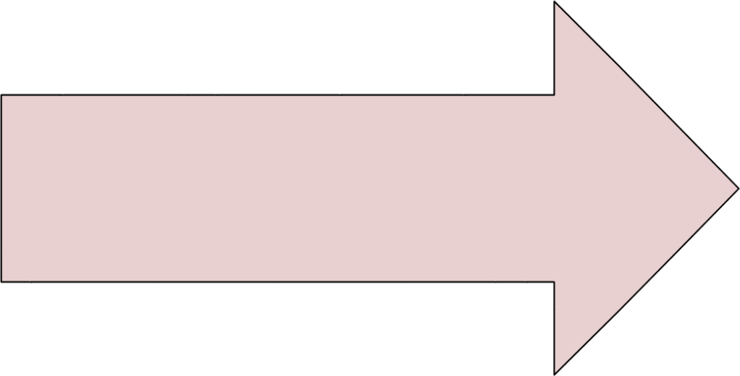

**AC supply**

**230**

**v/50hz**

**Transformer**

**(**

**step**

**-**

**down)**

**Diode**

**Rectifier**

**Filter**

**Circuit**

**Voltage**

**Regulator**

**Display Unit**

Figure 3.1: Circuit Block Diagram

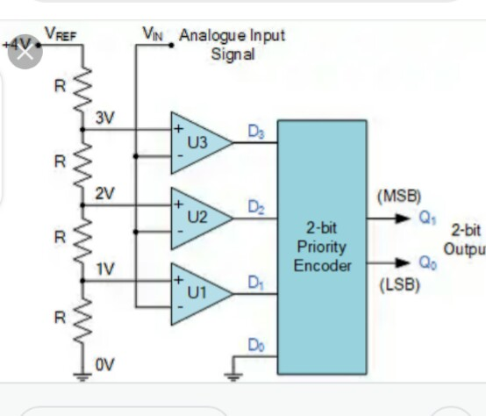

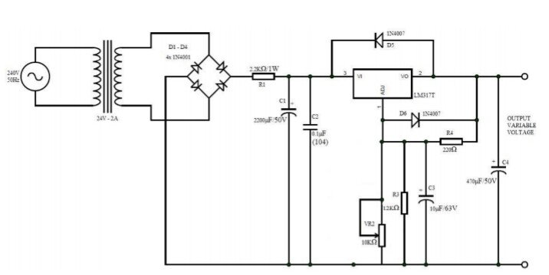

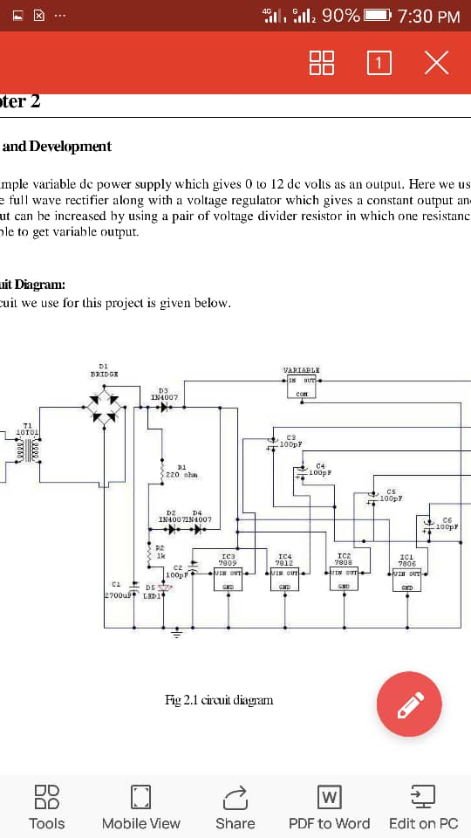

Figure 3.2: Circuit Diagram

**REFERENCES**

A.K. & B.L. Theraja (2008). Electrical Electronics Technology

Adeife T.O & Osemekillali, O. (1996). *Electronic Engineering Fundamental voll*. Ademola printing press, Osogbo Osun State Nig.

Circuit Theory and Analysis by Abhijit Chakrabarti

Encyclopedia of Electronic Components by Charles Platt

Green, D.C (1995). *Electronic technology* 5th edition long man Scientific and technical long man group Ltd. Long burnt mull.

Hoftman, J. (2013). Power supplies and application. MacGraw Hill publisher, New York USA.

John, H. (2020). Power supplies electronics club, *International Journal of Advances in Applied Science Research, 4*(1):515-522.

Paul, S. & Simon, M. (2001). Practical Electronics for inventors

Robert, L. & Louis, N. (2004). *Electronic Device and Circuit Theory*. Eight Edition, Prentice Hall of India Private Limited, New-Delhi

Study, M. (20014). *Design of a 0 to 30v regulated d.c power supply*. Retrieved March 27th 2017: from http:/www.sturdymafia.org./ps/30_contents.htm

Theraja, B.L and Theraja, A. K. (2002). *A Textbook of Electrical Technology*. 23rd ed.s. Chand: New Delhi, India.

Wdwuard, I. (1995) *Electrical technology* 7th edition long man Singapore publisher P.T.O